18 B 2024

There are things that make life possible. There are things that make life worth living. Food and water and shelter make human existence possible. But what makes life sweet, and beautiful, and rich? Today’s Gospel holds the clues.

Just last Sunday we participated in the Miracle of the Multiplication of the Loaves and Fish. Jesus had compassion for an overflow crowd of people and provided this outdoor picnic for them. He then left and headed for the town of Capernaum on the other side of the lake.

Our story picks up the narrative when the large numbers of the well-fed hopped into boats and went searching for Jesus. They were craving for more of the tasty bread and fish Jesus gave them the day before. There are things that make life possible. And for the people, it was within their reach, like today’s food truck!

But for the things that make life worth living. This, I believe, is to what Jesus was directing their attention—a hunger in their souls—that no quantity of food could satisfy. They needed to go deeper to find it. Jesus invites them to shift their expectations from outward signs to *inner transformation.* They asked for a sign so that they may see and believe. Jesus, the very Bread of Life, is standing before them. But they do not see Him as such. Jesus tells them that the same God who provided for their ancestors in the desert is the same God who fed the crowd today, and who makes life sweet, beautiful, worth living, and who gives life to the world.

To come to Jesus and to believe in Him requires letting go of familiar habits, like filling up on *“food that perishes,”* and allowing the Lord to *“give food that endures for eternal life.”* Seeking the imperishable food of eternal life, we recall Jesus saying: His food is to do the will of the One who sent Him; one does not live on bread alone, but by every word that comes from God; to seek first God’s will and justice, is to find all other needs being met.

These sayings of Jesus give us a clearer perspective on Manna, on Miracle, on the Eucharist: a new way of thinking about “spiritual food;” a new way of thinking about grace; a new way of thinking about the sharing of divine life.

A life of faith begins the journey of inner transformation. The Eucharist nourishes the call to deeper, fuller discipleship. The reception of divine nourishment is the gift of becoming food for others, the power of sustaining and nourishing.

And then take on an entirely new way of life—a God-fashioned life—a life renewed from the inside and working itself into your conduct as God accurately reproduced His character in you.

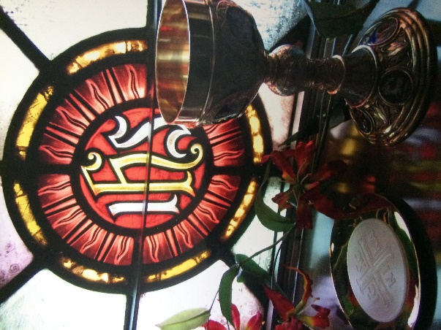 The Admonitions of St Francis are practical applications to the ordinary experiences of daily life. Admonition 1, v 19: As Jesus revealed Himself to the apostles in true flesh, so He reveals Himself to us now in sacred bread. And as they saw only His flesh by an insight of their flesh, yet believed that He was God as they contemplated Him with their spiritual eyes, let us, as we see bread and wine with our bodily eyes, see and firmly believe that they are His most holy Body and Blood living and true. And in this way the Lord is always with His faithful, as He Himself says: *“Behold I am with you until the end of the age.”*