19th Sunday in Ordinary Time, Year B (2024)

Food is a basic human need that has sustained each of us since we were born. It speaks of loving and caring, giving and sharing, living and growing, and even dying and rising. Through the giving and receiving, we establish and strengthen relationships. When those relationships are strained, the sharing can even renew the ties that bind us one to the other.

Today’s Gospel from St John is a small part of the larger teaching on the Bread of Life. There are many kinds of hunger: the hunger that I just spoke of: for food and drink that offers physical sustenance; the hunger for justice and freedom; a hunger for friendship and recognition and personal dignity; a hunger for purpose in life, and for hope in the future. And, there are many kinds of nourishment, and many ways of being bread or sustenance for others.

We are presented with the story of one of the Old Testament’s greatest prophets, Elijah, who appears hungry. An angel is dispatched offering him a hearth cake and some water. But his real hunger was for hope, and for a purpose in life. His situation in many ways is very much like ours today. The broom tree under which he sat is suggestive of the dark cloud of terrorism, racism, sexism in our culture that threatens to annihilate the future for young and old alike. His death wish is no stranger in our midst.

But the spirituality of food is full of implications that go beyond physical nourishment: food recalls the Manna in the desert, and a reminder of God’s faithfulness and love at all times and in all circumstances; food is a gentle act of hospitality, and gives a taste of the goodness of God, and the goodness of human existence as God’s creation. Now we can see Elijah drawing strength from the gift of hospitality. He receives not only physical strength, but hope and courage to meet the future and to respond to his own calling. The life-giving gift of “Fraternitas.”

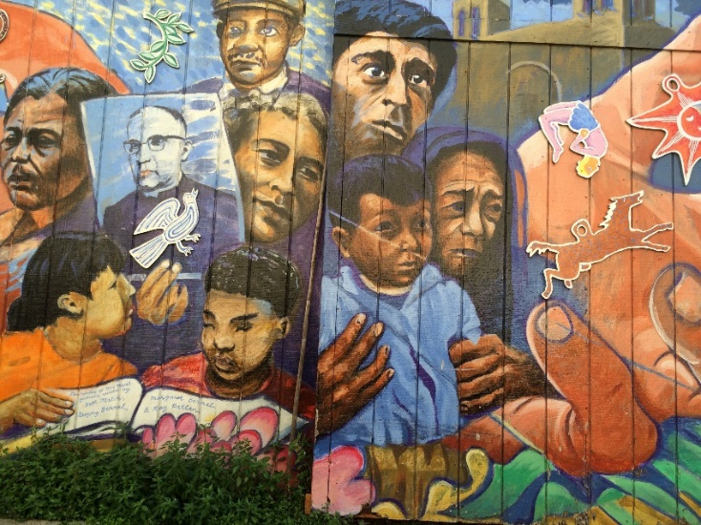 Beneath all our hungers is our hunger for God. Jesus is God’s offer to satisfy that hunger. The faith and trust Jesus is inviting us to, is not an intellectual assent to dogma, or doctrine. The Discourse of the Bread of Life is not about propositions. It’s about Jesus.

In Jesus, God the Father shares His very self with us. In Jesus, God the Father knows our pain and suffering, and has suffered death. Our faith draws us to see in Jesus God’s gift of eternal life. Faith in Jesus is our surest peace that God will not disappoint, that whatever happens to us will not overwhelm us, that evil and despair will not prevail.

God is alive and active, working in the lives of our sisters and brothers all our life-long. But like Elijah, we don’t feel it. He plops down, worn out, filled with despair, and wants to meet his end. The story of our lives, too. But then, God provides. Physical and spiritual nourishment are given. Jesus is the food we need, not only for the journey, but also for the desire to get up and begin the journey again.

Fraternity strengthens our faithful witness to the words of our Profession, and to the Gospel. When we meet opposition, when our spirits weaken, God offers us new nourishment—the life of Jesus, for us and for the world.