2 C 2025

*“Consider, O human being in what pre-eminence the Lord God has placed you, for He created and formed you to the image of His beloved Son according to the body, and to His likeness according to His spirit. All creatures under heaven serve, know and obey their Creator, each according to its own nature…”* (Admonition 5).

The dignity of the human person in the totality of his/her being, body and spirit, is founded on the love that dwells in the heart of God, who wanted as a partner a being similar to Himself, although radically different. St Clare writes that human beings *are the most worthy of all creatures. Even when they turn away from God, and show themselves to be ungrateful and evil, God did and does everything good for them. Just as God has created and redeemed them, He will save them by His mercy alone* (1RegNB 23,8).

Today’s Gospel is the story of Cana’s Wedding Feast. It involves symbolism. It begins with a time designation—“on the third day,” not a 24-hour day, rather, a symbolic sequence. The first day is the beginning; the second day is the middle; and the third day is the end. The third day symbolizes the fulfillment of the activities of the first and second days, and the start of something new. It’s a transitional day. Something is ending and something is beginning. This “third day” of transition is overseen by God. It is a “manifestation in time” of the divine plan.

This transition is happening at a wedding where the mother of Jesus is present. On the surface level, a wedding is an event where two, male and female, become one in order to create a third. Weddings are about human love that co-creates human life. On a deeper level, a wedding where the mother of Jesus is present, symbolizes the relationship between the divine and the human, how the two embrace each other to create vitality. The wedding symbolizes how God and people are united in love to co-create spiritual life.

The mother of Jesus is the spokesperson for the people-side of this divine-human relationship. She is humanity unaware of its lack, conscious that it cannot live to the fullest without continual communion with God. And so, Mary speaks to Jesus, the God-side of the divine-human relationship, those haunting and direct words of all human insufficiency, *“they have no wine.”* Humans have lost their union with God and their union with one another. Without this spiritual union the wedding of life cannot continue.

*“They have no wine.”* Words of human need, spoken by the mother of Jesus, are echoed by all who seek the presence of God as a remedy for humans for what is lacking: the royal official will say, *“come, Lord, before my little boy dies;”* the lame man describes his helplessness as, *“I have no one to put me into the pool;”* in the face of the overwhelming number of people, Philip realizes the scarcity of money and bread, *“six months’ wages would not be enough for each of them to get a little;”* even though he has been healed, the blind beggar remembers, *“I was blind…;”* Martha and Mary send a message to Jesus, *“Lord, he whom You love is ill.”* These statements combine to create a chorus of human afflictions. Cries of finitude—illness, blindness, being lame, hunger and death. The human condition is so jeopardized that people cannot celebrate.

The symbolism continues. In response to Mary’s bold statement of lack, Jesus addresses His mother as *“woman.”* He recognizes her as Eve, the mother of the living, who cares for her children. Her responsibility is to seek their well-being. And when Jesus asks her how this imperiled human condition whom she represents, is connected to God whom Jesus embodies, it is a question that sets up the revelation of His glory. Jesus’ glory is to bring divine abundance into the world of human lack. The incarnate love of God has come to prevent perishing: *“For God so loved the world that He gave His only Son, so that everyone who believes in Him may not perish, but may have eternal life…that the world might be saved through Him.”*

The answer to the question, *“What concern is this to you and Me?”* is everything. The very reason for the presence of Jesus is to supply wine for the imperiled marriage of divine and human life.

But the fullest revelation of how divine love embraces human lack will take place at Jesus’ *“hour.”* Jesus acknowledges this hour has not yet come. This hour holds the clue to the way divine and human are united, whenever human need and divine love face each other.

Early in the Gospel, the disciples of John follow Jesus and ask, *“Where do You live?”* He invites them, *“Come and see.”* St John says, Jesus lives *“close to the Father’s heart.”*  So, the invitation to the disciples is to enter into Jesus’ relationship with the Father, and to receive God’s love. But later in the Gospel, when Jesus asks where they have buried Lazarus, the tables are reversed and *Jesus* is told, *“Lord, come and see.”* Then, when Jesus sees the sisters and the Jewish people weeping, Jesus himself weeps. Now, Jesus is one with those He loves. Jesus himself has entered into the vulnerability of human existence.

This is the way of divine love. Divine love does not save from the outside, or by overwhelming force. Divine love compassionately shares human suffering that saves from the inside. The condition for making good wine at Cana’s wedding feast is drinking sour wine on the cross of Golgotha. This is the truth of Jesus’ hour.

At the beginning of this homily, I mentioned that this event is transitional, that something is ending and that something is beginning. Now, the transitional nature of the revelation comes into focus.

At Jesus’ instruction, the six stone water jars, used for ceremonial washings, are filled to the brim with water. The emphasis is no longer on the water washing the outside of a body but on water filling the inside of the jars to the max. This is the beginning of the abundance of grace that wells up from within, a fullness that characterizes the Spirit, *“The water that I will give will become in them a spring of water gushing up to eternal life.”* At Cana, when the water gushes up to eternal life, it becomes wine. Wine is the symbol of the Spirit, vivifying the entire human person from within. The divine and the human are related, and kept in communion by the divine Spirit entering into the threatened human condition and supplying what it needs.

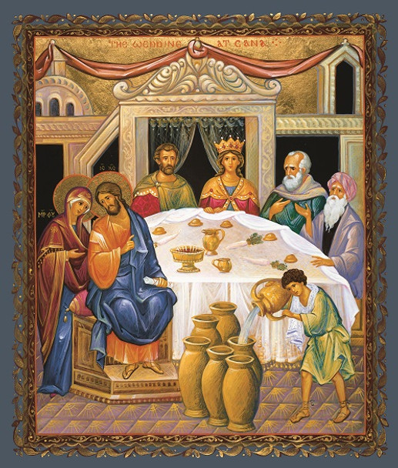 In a concluding remark, St John calls this action of Jesus a *“sign.”* A sign works on two levels: there is the surface level, the literal, the physical available to the five senses; and there is the deeper level, spiritual and symbolic that invites to follow the clues on the surface in order to experience the Christian revelation. We have the tendency to stay on the surface, to be dazzled by what we see, hear, touch, smell and taste. The change of water into wine in this story is completely downplayed, almost an afterthought. It is casually mentioned within the context of another activity—tasting—when the chief steward tasted the water that had become wine. No spotlight on the transformation. The change is slipped in. St John is more interested in revealing the divine and the human are married to one another than in the excitement of a miracle.

The dynamics that are found in this first of signs will be woven throughout the Gospel—the transition from exterior religion to interior faith, the many faces of imperiled human existence, divine love compassionately entering human life to save it, and those who can read the signs and come to belief.