2 C Lent 2025

Things are often different than they seem. It’s amazing how often we present ourselves with an incomplete picture of who we are, who other people are, and what is the true condition of our surroundings. We can know someone for many years and then find out there is something about that person that we didn’t see. Someone that we always trusted, someone we never understood, then suddenly steps forward and surprises us. And when this new truth hits us, we become confused and disorientated.

On the mountain of the Transfiguration, we see what is there, and the way we see what is there. There is the reality, and then there is our perception of it. The disciples experienced ordinary life with Jesus. They traveled with Him, they ate with Him, they listened to His teaching and watched Him curing and healing the sick. Like all human beings, they are creatures with meaning and purpose to be achieved beyond what they presently are. Self-sufficiency is not enough. On our journey we, too, strive on the way to a life that is more than what it is at any stage of the journey.

But this day, on the mountain, something is different. This day Jesus is transfigured before them. His face changes. His clothes become dazzling white. He speaks to Moses and Elijah. This is not an ordinary day. For the time they spent with Jesus, they experienced the ordinary. In a flash, they now experience the transcendent.

Today’s Gospel presents an interplay of reality and perception, between the ordinary and the transcendent. As humans we are oriented toward God in knowledge, action, and love, to desire God. Prayer expresses our awareness as dependent creatures. Jesus stands enveloped in light, overwhelming light, glorious light. His garments become white with a brightness that is dazzling.

And yet, with all this light, the disciples do not understand, do not see Jesus in a new way. Faith leads them to see Jesus in a deeper way. Light is one thing, faith is another. What will we do with the light which God gives us? What shall we see? The Gospel invites us to see people and our world in a deeper way, to look beyond the surface, and to perceive the reality that lies deep within.

St Francis, in the form of a prayer, acknowledges his creaturehood. As he turns to God with his intention of giving glory to the Source and Goal of all existence, Francis breaks out in a prayer of praise, overwhelmed with the sense of Jesus’ transcendent goodness: *“Let all of us wherever we are, in every place, at every hour at every time of day, everyday and continually, believe truly and humbly, and keep in your heart and love, honor, adore, serve, praise and bless, glory and exalt, magnify and give thanks to the Most High and Supreme eternal God, Trinity and Unity, the Father and the Son and the Holy Spirit, Creator of all, Savior of all who believe in Him, and hope in Him, and love Him, who is without beginning and without end unchangeable, invisible, indescribable, ineffable, incomprehensible, unfathomable, blessed, worthy of praise, glorious, exalted on high, sublime, Most High, gentle, lovable, delectable, and totally desirable above all else forever. Amen.*

Reality is seen from the perception of faith. We believe that at the heart of every person and every created thing lies the goodness and the glory of God. Divine light shines all the time. What a difference it would make if we would be willing to see that deep inner reality, the glory of God that is always around us.

Whenever we follow someone resonating more light than ourselves, we should be open to what they say. We are not to be gullible or mindlessly obedient, but willing to suspend our own assumptions to work with words that may be strange to us. Jesus has greater wisdom and courage than His followers. We must realize this, and risk deeper listening. Listening to the Word of God through Gospel stories, let us cultivate that openness. These are invitations to a deeper level of wisdom.

St Francis captured the essence of the human being as made to love God. Giving praise and glory to God defines us. Human desire wants what is “delectable and totally desirable above all else.” All of creation gives glory to God simply by existing, but human creatures praise God by being human.

The Gospel’s spiritual wisdom, a wisdom that conflicts with conventional understandings and preferred ways of behaving, is letting go of some certainties. Listening to Jesus leads us to greater life and love. Jesus has the words of eternal life. Let us know and claim the transcendent aspect of our lives, knowing that we find there a deeper meaning. It is in this deeper meaning that we find God. We can both agree that our lives are filled with doing ordinary things. The Transfiguration event reminds us that the ordinary can have a larger meaning, a transcendence.

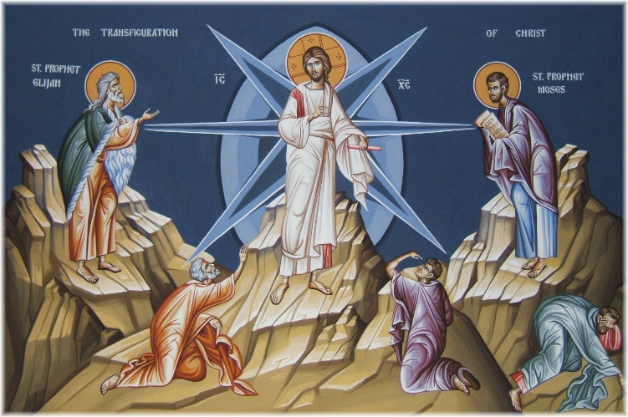Let us place ourselves with Jesus on the mountain. It’s there that we come closest to recognize who Jesus really is, and who we really are. What a difference it would make in our life if we would allow ourselves to see that deep inner reality, the glory of God, that is always around us.