4th Sunday in Advent – Year C

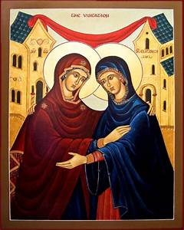 Our OFS theme, “Listen, Discern, Go Forth,” is manifested in the hearts of two women—Elizabeth and Mary—in this Sunday’s Scripture readings. Elizabeth, and her husband Zechariah, both come from priestly families. Elizabeth is pregnant with a child who will become a prophet. She represents both the priestly and prophetic traditions of Israel. So, when the infant in her womb leaps for joy at Mary’s greeting, and when she asks, *“But how does this happen to me, that the mother of my Lord should come to me,”* priorities are made clear. Mary carries the fulfillment of Jewish history. The promise at the heart of Israel’s faith, both its priestly and prophetic traditions, is Jesus.

The presence of the Divine is everywhere in these joyful mysteries. But I would like to consider the human response to such initiatives. In Elizabeth’s praise of Mary, she is blessed because she has learned to trust the process of hearingthe Lord’s word with such attentiveness that it leads to fulfillment. Mary has just experienced a mind-boggling conversation with the angel Gabriel. In a surprise visit, he greeted her as a reality bursting with grace, destined to be involved in a divine plan. This troubled her, but she did not dismiss it. She pondered his strange address of “full of grace” and “the Lord is with you.”

Gabriel continues, telling her not to be afraid, spelling out the mission in detail, conceiving and bearing a son who will inherit the throne of a king, the house of a patriarch, and lead a kingdom that would never end. The angel spared no superlatives, only the facts. The mission is about God, history, and the future of the world. God is the director, and the characters are in line with their parts.

Mary protests she did not have the necessary physical prerequisites, that she is not qualified. The angel counters her objection with the promise of the Holy Spirit who would provide whatever was needed. This is God’s doing. The angel strengthens his case by mentioning Elizabeth, her relative, is already on board—the barren one is bearing a son—and says nothing is impossible with God. Mary says “yes,” a courage that opened her heart and soul. The angel departed, and Mary “set out and traveled to the hill country in haste.” *Listen, discern, go forth.*

Weaving the central characters and their experiences into this divine tapestry, imposing, ephemeral angels carry out God’s plan. Angels arrive unexpectedly, leave suddenly, and the ones whom they visit find themselves changed. Here they are found pregnant. We need down-to-earth conversation time to process what has happened and evaluate it, with someone who respects the experience. And so, Gabriel has dropped the name Elizabeth, and Mary has picked up on it. Mary is not hastening to the house in Judea with a nose for news, to check out the angel’s story. Is Elizabeth really pregnant? I believe she is looking to explore her transcendent experience with someone who knows about them. But our conversations give way to Mary’s greeting that triggers the Holy Spirit in Elizabeth. Her loud outburst not only tells Mary all she needs to know. Mary’s motherhood begfins. In both the narrative and Elizabeth’s witness, the connection is made between the greeting and the infant leaping for joy. Mary’s salutation activates what is growing in Elizabeth, what is coming to birth in her. What is growing in her is God-directed. Humility and lowliness are the proper responses. These interior attitudes form our Franciscan vocations, and open the door between human impossibility and divine possibility.

In the highly poetic early centuries portraying the Annunciation, a small bird (dove?) could be seen on Mary’s shoulder. It was said that Mary conceived through the ear. Could it be that the Word of the Lord spoken by Gabriel and heard by Mary that initiated the pregnancy. We believe the Mary conceived in her heart. In other words, she pondered the Word of the Lord in the space—mind and heart—where the human person is connected to both God and to the world of action. Mary also conceived in her womb—that the Son of the Most High took flesh in the human condition.

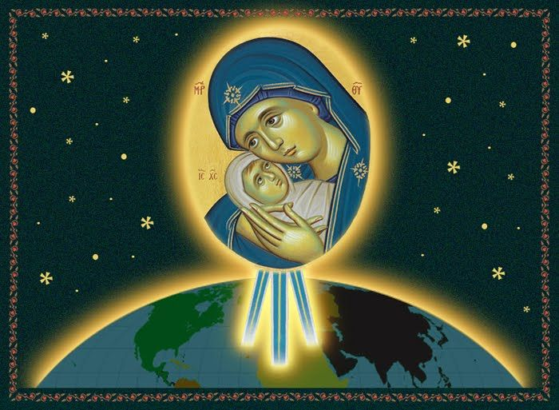

In the Incarnation, Mary heard the word in her ears, pondered its deeper meaning in her heart, and embodied it in action, conceiving the Word in her womb and giving birth. Mary listened, discerned, and went forth. Through her intercession as a mother ever ready to help us, may we follow her example and bring her Son to the world and the world to her Son.