4 B 2024
Today’s readings invite us to reflect on the communication that takes place between God and us. Our desire to live in an ongoing relationship with God, and God’s desire to give grace and healing to us.
Power, authority and efficacy are in the words Jesus speaks. He simply speaks, and His presence is enough. We are blessed when we develop and sharpen our ability to Listen, Discern, and Go Forth to respond appropriately, giving what we have received. Perhaps, then, our words and our lives manifest the same presence of Christ in our communities, in our fraternities, and in our families.
At Mass at the retreat center, Father Marek referred Jesus as “the Perfect Friar Minor, the Perfect Lesser Brother.” In striking simplicity St Francis fascinates us, inspires us, challenges us, confronts us with his simple-minded purposefulness, and the open transparency of his life-choice. We read the story of Francis, we become familiar with an extraordinary life lived by an extraordinary man, in extraordinary times, and the extraordinary impact he has made in the life of the world, and we ask, is this man for real?
We encounter Francis as real, real as you and me, no more, no less ordinary as you or me: a person with dreams, hopes, expectations; a person with a life, a history; a person of success, a person of failure, a person who embodies everything that is noble and fine and good in the human condition, a person who suffered the deepest, and darkest depression in a sense of self-failure. An extraordinary individual in an ordinary life, transformed by a desire to be as Christ-like as possible.
Francis wanted nothing other than to follow in the footprints of Jesus, the literal following of Jesus. For Francis, Jesus was the poor, humble Christ so dramatically imaged at Greccio. The Christ who was born without possessing anything, who grew up without possessing anything, who lived without possessing anything, and who dies without possessing anything. It was Christ who emptied Himself and took the form of a slave. For Francis, it was the servant Christ, not the kingly Christ. It was the Christ who had nowhere to lay His head. It was Christ, “the Lesser Brother,” as Father Marek said, who had come to serve and not to be served. It was the lowly Christ, the One meek and humble of heart from whom we are to learn.
Our Franciscan vocation is to be challenged by everything that disturbs us, to encounter everything that challenges our sense of what is rich and poor, what is central and crucial to us and what is superfluous. Our journey is to encounter the truth and reality of what it is we can become, what we have not become but what we wish to become.
Francis is one who had it all: wealth, finery, splendor, every material comfort, and who threw it all away. For what the world of his time and the world of ours considers to be all those things necessary to make us content and happy, were all rejected by him. His happiness and contentment was in the having and then not having, in never desiring the attractive things in life. In his radical emptying of his life that he possessed everything. And everything for Francis was Christ, Christ Himself who is the Gospel.
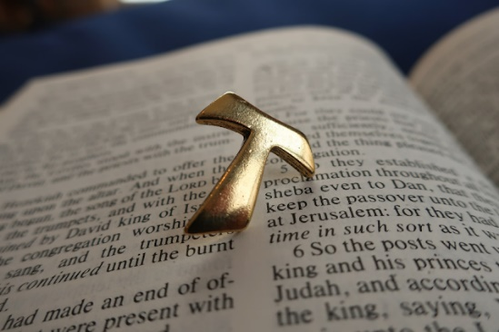
In possessing Christ, he satisfied his deepest longing and desires. We who claim to be Franciscan, that desire must also be ours, and to live with the same conviction: “I desire nothing more than to follow in the footsteps of our Lord Jesus Christ.”

