5 C 2025

The crowd is eager to hear the Word of God. Jesus looks about for a pulpit—two boats there at the lake will do. The purpose of hearing the Word is to be “caught” by it, to have it illumine the mind and inspire the will so that it changes one’s thinking and acting.

Teaching from the boat is symbolically appropriate. When fish are caught, they move from darkness beneath the sea into light. So those who hear Jesus’ teaching will be pulled from darkness into light. In particular, Jesus will reach into the interior darkness and release a fullness beyond what they had previously known.

A story. It is known by everyone who cares to hear the story that Jesus and St Peter used to retire to the local tavern after a hard day of ministry, to break bread and drink wine together.

On a certain rainy night, St Peter turned to the Lord and grinned, “We’re doing real good.”

“We?” asked the Lord.

Peter was silent. “Alright, You’re doing real good,” he finally said.

“Me?” asked Jesus. Peter pondered a second time. “Alright, God is doing real good,” he finally admitted.

But the Lord saw how reluctant Peter was to admit the Source of all goodness. He laughed and hit the table with His fist.

It was the laugh that got to St Peter. He pushed his face toward Jesus and blurted out, “Look, I was somebody before You came along. Now, everybody says, ‘There goes Jesus and His sidekick Peter. Jesus cures them and Peter gives out holy cards.’ But it wasn’t always that way. People knew me in my own right. I was respected and looked up to. They would say, ‘There goes Peter, the greatest fisherman in all of Galilee.’”

“I heard that you were a very good fisherman, Peter,” said Jesus who was always quick to praise.

“You’re darn right I was. And tomorrow I’m going to prove it. We are going fishing, and You will see how the other fishermen respect me and look to my lead.”

“I would love to go fishing, Peter. I have never been fishing,” said the Lord, who was always looking for new adventures. “But what will we do with all the fish we are going to catch?”

“Well,” Peter smiled the smile of the fox. “We’ll eat a few, store the rest, wait till there is a shortage, then put them on the market at top dollar and turn a big profit.”

“Oh,” said Jesus, who had that puzzled and pained look on His face that Peter had often observed, as if something that had never crossed his mind just made a forced entry. Peter wondered how someone as obviously intelligent as Jesus could be so slow in some matters.

The next morning at dawn Jesus and Peter were down at the shore readying their boat. And it was just as Peter had said. When the other fishermen saw Peter, “Going out, Peter?” they asked. “Mind if we come along?” “Why not?” shrugged Peter, pretending to be bothered by them.

Peter’s boat led the way. Jesus was in the prow hanging on tightly. Peter was a scientist of a fisherman. He tasted the water, scanned the sky, peered down into the lake, pointed off to the side, and gave the word in a whisper, “Over there.”

“Why isn’t anyone talking?” asked Jesus in a voice much too loud for the quiet work of snaring fish. “Shhh!” Peter put his finger to his lips and glared at Jesus. The boats formed a wide circle around the area Peter had pointed to. “Let down the nets,” Peter’s voice crept over the surface of the water.

“Why don’t they just toss the nets in? blurted the Lord, who had hopes of learning about fishing. A second Shhhh! came from Peter.

The fishermen let down their nets and then began to pull them in. but something was wrong. The nets rose quickly; their arms did not tighten. All they caught was water.

The fishermen rowed their boats over to Peter. They were angry. “The greatest fisherman in all of Galilee brought us all the way out here for nothing. We’ve wasted the best hours, and we have nothing to show for it.” And Jesus said nothing.

Peter tried a second time. He checked the nets, scanned the sky, tasted the sea, and peered into the depths. At long last he looked at the Lord Jesus and, pointing out into the lake, said, “Over there!” And all day long Jesus and Peter rowed from place to place on the sea of Galilee, letting down their nets. And then hauling in their nets, they caught nothing.

Evening came and they made for shore. It was then, as the boat glided toward shore, that it happened. All the fish in the sea came to the surface. They leapt on each side of the boat, behind and in front of the boat. They surrounded the boat, escorting it toward the shore.

When the boat arrived at shore, it was brimming, creaking, sinking under the weight of the huge draft of fish. The other fishermen were waiting. They gathered around Peter and each in turn hugged him. “Peter, you scoundrel! You knew where the fish were all the time and never let on. You rogue! You put us on. You are surely the greatest fisherman in all of Galilee.”

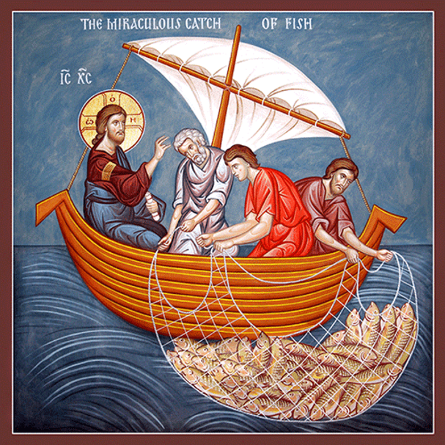Peter was uncharacteristically silent. He only said, “Give the fish to everyone. Tonight, no home in the village will go without food.” After that, Peter said nothing.

But later that evening, at the tavern with bread and wine between them, Peter looked across the table at Jesus and said, “Go away from me, Lord. I am a sinful man. But Jesus smiled, a smile that moves heaven and earth. Jesus had no intention of going away. There were other fish to catch.