KEYNOTE SPEAKERS

**David B. Couturier, OFM Cap.**

**Bishop John Stowe, OFM Conv.**

**Doug and Marion Clorey, OFS**

**Tim and Kathy Taormina, OFS**

**Lori Hinker, OFS**

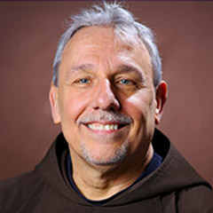

**David B. Couturier, OFM Cap.** is Dean R. Hoge Professor of Pastoral Planning and Church Management. He teaches in the Department of Franciscan Studies at St. Bonaventure University in Olean, NY, and is Professor in the Department of Theology at the Pontifical Antonianum University in Rome. Father Couturier is the author of: *The Four Conversions: A Spirituality of Transformation*. The book will be the topic of his presentation.

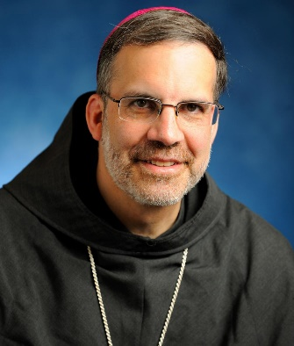

**Bishop John Stowe, OFM Conv.** was ordained as the third Bishop of the Diocese of Lexington, KY in 2015. His keen awareness and active participation in today’s opportunities to follow the Gospel and live our Franciscan lives of mercy and forgiveness will stir us to ponder how we can improve our involvement in our individual communities to hear the marginalize and address their needs and be their voices when they cannot be heard.

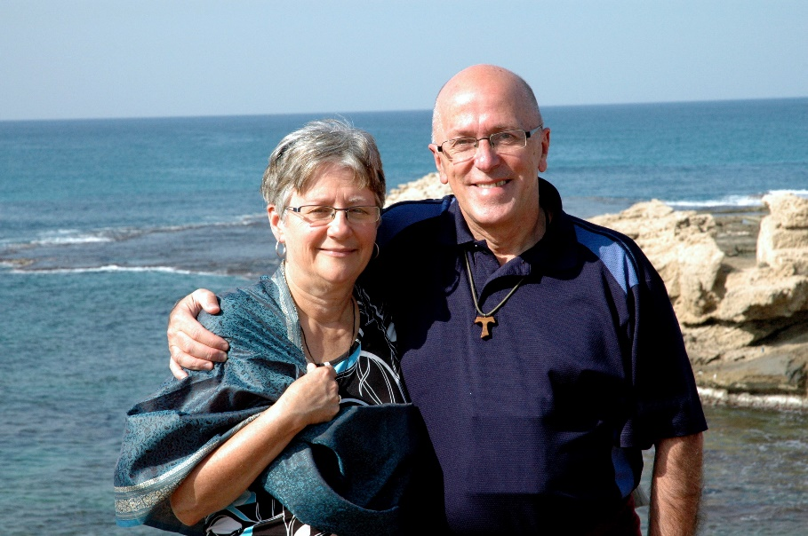

**Doug and Marion Clorey, OFS** reside in Prince Edward Island, Canada and have been married for 45 years.  They are the parents of four children, John, Christina, Monica and Clara, and grandparents of Arya and Calista.  Both were professed as Secular Franciscans in 1987.

Doug has worked as a teacher, information technology professional and as a senior manager with the Government of Canada.  He retired from his professional work in 2009 to serve on the OFS International Presidency for 12 years.  He served for 6 years as Presidency Councilor for English-speaking Europe and North America (2002-2008) and for 6 years as Vice-Minister General (2008-2014).  He also served on the Franciscans International Board of Directors (Vice-President 2009-2012 and President 2012-2016). He currently serves as National Minister of Canada.  Over the years, he has also served his local parish community in a variety of capacities.  Doug is a musician (piano/guitar/composition) and enjoys walking, cycling and skating.

Marion's background is in education and she has taught at all levels from kindergarten through university. She worked in family education and marriage preparation before returning to school to receive her professional counselling designation. She recently retired from the University of Prince Edward Island where she worked as a mental health counsellor. Marion has served her OFS community at both the local and national levels in various capacities. She was Canada's International Councilor from 2012- 2018.  She is also active in her local parish as a song leader. She has served as a National Board Director for the Canadian Counselling and Psychotherapy Association and is a current member of the Saint Dunstan's University Board of Governors. Marion enjoys walking, reading and yoga. Spending time with her grandchildren is her most favorite thing to do!

**Tim and Kathy Taormina, OFS** reside in Apple Valley, Minnesota and have been married for 43 years. They have four grown children and four grandchildren. Kathy was professed in 1994 and Tim professed in 2006.

Tim currently works for Delta Airlines in their IT division as a Senior Analyst. He retired from the United States Air Force after serving 30 years, active duty and as a reservist. He served as Vice Minister and Minister to his local fraternity, served three years as the Queen of Peace Regional Councilor and is currently serving nine years as the Queen of Peace Regional Vice Minister. Tim serves in his local parish as a Eucharistic Minister and a 4th Degree Knight of Columbus. Tim and Kathy are serving on the 2021 Q Core Committee. Tim enjoys travelling the world with Kathy and golfing.

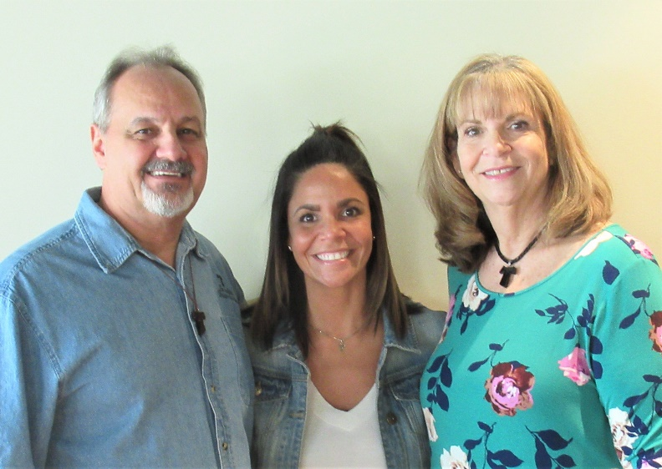Kathy’s background is immersed in youth. She was a stay-at-home mother to four and cared for many more children through the years, even fostering with Tim. She served her parish in youth ministry for over 20 years and has served Franciscan Youth for more than 15 years. She has served as a local Minister and a local and regional Formation Director. She served as a regional Franciscan Youth/Young Adult (FY/YA) Fraternal Animator and served the National Fraternity as a National Councilor (2003-2006), as a member on the FY/YA Commission (1996-2002) for 6 years and then served for 6 years as the Commission Chair (2003-2009). She led FY/YA members to five Franciscan World Youth Days representing the OFS-USA. She currently serves as the Queen of Peace Regional Spiritual Assistant and as Spiritual Assistant to the FY/YA Commission. Kathy enjoys traveling, jewelry beading and flowers, using her 16 years of experience employed in a flower shop.

**Lori Hinker, OFS** (Daughter of Tim and Kathy Taormina, OFS) is the Director of Middle School Faith Formation and Youth Minister at St. Michael’s Catholic Church in Minnesota and a Religion Teacher for the school since 2016. She was professed into the Secular Franciscan Order in 2006, and has been serving as the Franciscan Youth/Young Adult Fraternal Animator/Commission Chair for the Queen of Peace Region for the past two years.  Lori attended three Franciscan World Youth Days as a representative for the OFS-USA. She graduated summa cum laude from the College of St. Scholastica with a Bachelor’s degree in Religious Studies and Theology in 2007. From there she was the youth minister at St. John the Baptist Catholic Church in Savage for five years, and the Pastoral Associate for Youth Formation at Mary, Mother of the Church in Burnsville for three years.  She became involved in youth ministry thanks to her mother, father, and 3 siblings. She was born and raised in Pittsburgh, Pennsylvania and is an avid Steelers fan. In her free time, she enjoys working out, cooking, reading, watching movies, and boating on Lake Minnetonka with her husband and dog.