Corpus Christi B 2024
The Church, as Mother and Teacher of the faith, has given all believers, in these days of Eucharistic Revival, the opportunity to reflect deeply on the Eucharist, to be concerned what happens on the Altar and what should be happening in the hearts of those around the Altar. We need to reflect and understand that we are the Body of Christ, receiving Christ’s body.
Many years ago, St Augustine preached a sermon about today’s Feast of the Body and Blood of the Lord, in which he said, “What you see is bread and a cup. This is what your eyes report to you. But your faith has need to be taught that the bread is the Body of Christ, the cup the Blood of Christ, yet it hungers for a fuller account of the matter.
Concerning our Lord Jesus Christ, we know the source of His flesh: He took it from Our Lady. Like any infant, He was nursed and nourished; He grew in age, wisdom and grace; suffered persecution from His own people. To the wood He was nailed; on the wood He died; from the wood, His body was taken down and buried. On the third day, as He willed, He rose; He ascended bodily into heaven, whence He will come to judge the living and the dead. There He dwells even now, seated at the right hand of the Father.
So, how can bread be His body? And what about the cup? How can it, or what it contains, be His blood? These realities are called sacraments, because in them one thing is seen, while another is grasped. What is seen is a mere physical likeness; what is grasped bears spiritual fruit. So now, if we wish to understand the Eucharist, listen to the Apostle (Paul) as he says to the faithful, ‘You are the Body of Christ, and individually members of it’ (1 Cor12, 27). If we are Christ’s body and members of it, it is our own mystery that is placed on the Lord’s Table. It is our own mystery that we are receiving. We reply ‘Amen’ to that which we are, and by replying, we give consent. For we hear ‘The Body of Christ,’ and we reply, ‘Amen.’ Be what you see and receive what you are.” (my italics)
Two truths are presented here: God who is hidden in the Eucharist, and the Body of Christ. In the First Admonition, St Francis says, “Behold, each day He humbles Himself as when He came from the royal throne into the Virgin’s womb; each day He comes to us, appearing humbly; each day He comes down from the bosom of the Father upon the altar in the hands of a priest. As He revealed Himself to the holy apostles in true flesh, so He reveals Himself to us now in sacred bread. And as they saw only His flesh by the insight of their flesh, yet believed that He was God as they contemplated Him with their spiritual eyes, let us, as we see bread and wine with our bodily eyes, see and firmly believe that they are His most holy Body and Blood living and true. And in this way the Lord is always with His faithful, as He Himself says: Behold I am with you until the end of the age.”
St Augustine said what you see is bread and a cup, but we know that God is there. Many centuries later St Thomas Aquinas would pick up on that notion of a hidden God when he wrote: “Godhead here in hiding, whom I adore, masked by these bare shadows, shape and nothing more, see, Lord, at Thy service low, lies here a heart lost, all lost in wonder, at the God thou art.”
“All lost in wonder…” I’m surprised, in awe, amazed and I marvel: how God is Three and One; how God could wed Himself to flesh in the womb of a virgin; Moses before the Burning Bush afraid to look at God; Our Lady, newly God’s mother: “My spirit rejoices in God my Savior;” St Francis receiving the stigmata; St Theresa ravished by a rose; doubting Thomas discovering God in the wounds of Jesus; St Mother Teresa spying the face of Christ in the tortured poor; a child casting a kite into the wind; a mother looking with love upon her newborn child. I can only welcome this hidden God in awe and delight. “Christ plays in ten thousand places, lovely in limbs, and lovely in eyes not His…to the Father…through features of people’s faces” (Eugene Peterson).

St Francis, in the conclusion of his Letter to the Entire Order says, “…O wonderful loftiness and stupendous dignity! O sublime humility! O humble sublimity! The Lord of the universe, God and the Son of God, so humbles Himself that for our salvation He hides under an ordinary piece of bread. Brothers, look at the humility of God, and pour out your hearts before Him! Humble yourselves that you may be exalted by Him! Hold back nothing of yourselves for yourselves, that He who gives Himself totally to you may receive you totally!”
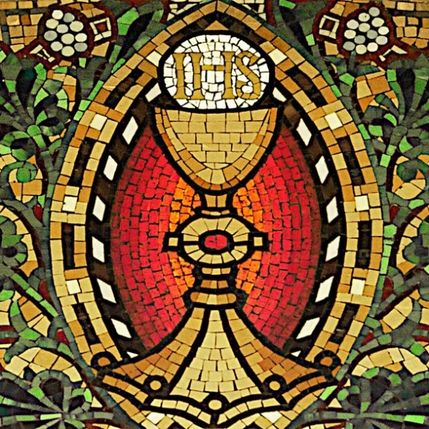
This is the mystery of our bonding to God the Father in Jesus in the power of the Spirit. Here we dwell with God and once we eat and drink, with Him and in Him, we are to be that bond in the world.

