Holy Family C

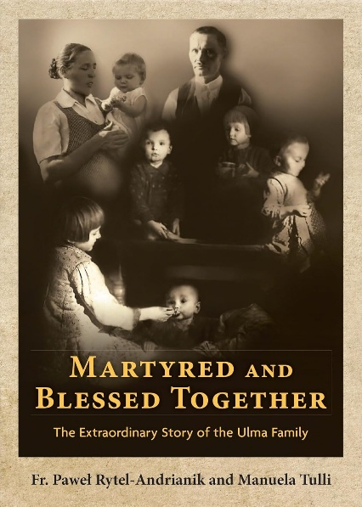On this feast of the Holy Family, I invite you consider a family from Poland murdered in 1944 by giving refuge to eight Jews by hiding them in their home for a year and a half. This entire family of parents Josef and Wiktoria Ulma and their children, including the unborn child she was carrying, was beatified as martyrs 10 September 2023 by the Church, a testament of their sacrifice, the first time an entire family was beatified together.

Around 4 o’clock in the morning on 24 March 1944 in Markowa, a town near Ukraine, German Nazis soldiers had one mission: to punish the entire Ulma family for violating German rules against giving any help to Jews. Moved by the commandment of love of neighbor this family extended mercy and compassion to the most vulnerable. Embedded in the pages of the family Bible, the word “Samaritan” was underlined, accompanied by a resounding yes. This was the family’s commitment to helping others in a world fraught with violence and division. Mother and father were executed in front of their children, with Wiktoria being seven months pregnant. The children were not spared, and the house was set ablaze. May the Ulma Family intercede for all our families. Amen.

*“To shine on those who sit in darkness and the shadow of death,*

*to guide our feet into the way of peace”* (Luke 1, 79).

Franciscans profess with their lives to bring the Gospel to people and people to the Gospel, so that the Prince of Peace may reign in human hearts. We belong to each other. Pope Francis has written encyclicals reminding us that we are all interrelated, interconnected, and interdependent. When anyone is hurting, we all hurt in some way. We cannot escape the effects of injustices on those living at home or abroad.

Rooted in both Scripture and the rich tradition of our faith, Catholic Social Teaching guides people of good will how to live as people of justice and mercy. Pope Francis urges us to draw close, to make ourselves the neighbor of everyone without exception. We encounter God in our encounters with one another. By building relationships with God, the human family and all of creation, we are called to resist violence, economic injustices, militarism, and environmental destruction. Empowered by the Holy Spirit we use our gifts to dispel fear and apathy, and to be stronger prophets for local and global justice.

In “Fratelli Tutti,” Pope Francis speaks of the need for men and women to boldly and creatively search for ways of peace for healing wounds, to initiate processes of encounter. The Holy Spirit is the prime “Activity Director.” His gifts are limitless and give increase to our lives as we enter more deeply into the mercy of God. The existence of each individual is deeply tied to that of others, offering care in our thoughts and actions. Life is a time for interactions, social friendships, offering patient endurance, strength when life’s crosses are heavy and enduring. Life exists where there is bonding, communion, fraternity, even-temperedness, tranquility, unpretentiousness.

When a family has fully embraced the virtue of humility, the floodgates of mercy are opened. Mercy received from God is meant to be given to others in a limitless way. Our relationship with God and the reception of His mercy becomes the foundation of our lives. As we grow in the love of God, the holiness we experience becomes the motivation of how we relate to one another. Each person God puts into our lives will experience God’s mercy through us in a way that God chooses. As we remain in God’s grace, bonds of love will form with all who are willing to receive that love. Such is the story of the Ulma Family. May God be praised.